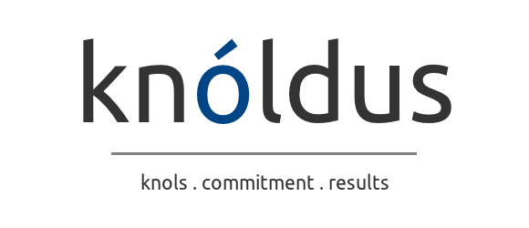

**Surabhi Soni**

**Sr Software Consultant**

4+ years of experience in Data Analytics, Data Visualization and Data Integration. Well versed with BI Reporting projects and developing BI Dashboards using Tableau. Designed the framework for delta load in IICS and also design the data flow at Taskflows level. Implementing dimension like SCD 1 and 2 using Informatica tools. Domain knowledge of Life sciences, Pharmaceutical business units. Working with clients, Onsite leads, business managers and technical teams for executing projects.

# **Skill Set**

* Informatica Cloud, Informatica PowerCenter
* Data Visualization - Tableau
* Postgre SQL
* Data Analysis
* AWS
* Microsoft Excel

**Recent Projects**

**Project: INFORMATICA CLOUD – Development**

Worked on Informatica Cloud tool which involves module development, designing, analyzing, workflow, gathering of information and processing of reports according to the requirement of pharmaceutical clients and the required database is Postgre SQL and to store the files used amazonS3(AWS).

**Responsibilities:**

* Actively involved in gathering and analyzing business requirements from the client perspectives and providing solutions and services for the same.
* Design, Develop and Test ETL Mappings, Taskflows using IICS.
* Achieving Test Converge more than 75% and maintaining the same at the time of enhancements and Preparation of Unit Test Plans.
* Developed and implemented strategies for the handling of errors by the ETL team.
* Responsible for executing weekly regular reports.
* Independently handling part of projects assigned with adherence to timelines.
  + Provision and maintenance of all documentation to support above activities.

**Project: CHC_GPT (Customer Health Care Growth Performance Tracker)**

# **Responsibilities:**

* Design, Develop and Test ETL Mappings, Taskflows using IICS.
* Worked on IICS, PostgreSQL, Control-M Scheduling tool, Amazon Web Services.
* Understanding of complex requirement of project and be a part of brain storming sessions for providing solution.
* Involved in Designing process of Data Warehousing, Stage layers and PSA layers.
* Unit Testing and Data Mocking
* Developed and implemented strategies for the handling of errors by the ETL team.
* Responsible for database schema design, integration testing and other projects that may be necessary to help the team achieve their goals
* Working closely with Onshore and offshore application development leads.

**Project: Tableau - Development**

Worked on to calculate all relevant insights & KPIs for patient level data (mainly we capture patient journey). We receive raw data from two data source HUB (through McKesson) and Specialty Pharmacy. Based on this raw data we create fact tables for relevant data through Alteryx in hive. And use these tables in Tableau for data visualization. Then we were revamped this project into Power BI.

# **Responsibilities:**

* Designed project workflow from initial to endstage
* Doing requirement discovery, understanding client queries, reviews and documentation
* This project is about to calculate all relevant insights & KPIs at patient level data.
* This project is about to capture & visualize patient journey data at deferent levels such as at SRF creation, BI, prior authorization, Appeal and Triage based in several programs.